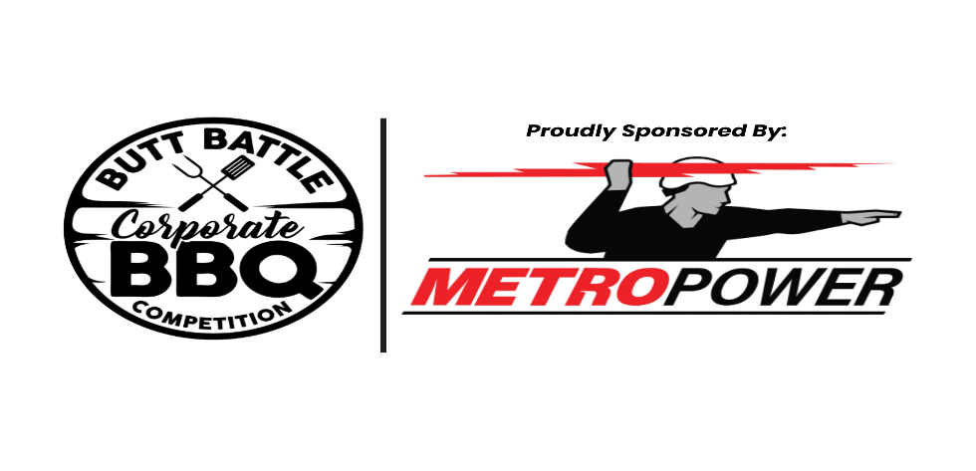
MARCH 14th, 2026

Entry Fee: $100.00 Location: Earle May Boat Basin Park, 100 Boat Basin Circle, Bainbridge, GA

Prizes:
Overall 1st Place - $500 + Trophy
Overall 2nd Place - $250
Overall 3rd Place - $100
Boston Butts 1st Place – Trophy
Pork Belly 1st Place – Trophy
Ribs 1st Place - Trophy

Contestant Rules, Responsibilities, and Judging:
- Three categories of meat are eligible for prizes: Boston Butt; Pork Belly and Ribs. All three meat categories must be entered to be eligible for overall placement.
- Each team shall provide their own supplies and cooking equipment. The presenting sponsor will provide the meat.
- Each team shall keep their cooking area in a clean manner. No animals are allowed in the cooking area. Cookers, tents, and other equipment must be kept within the boundaries of the team’s assigned cooking space.
- All competition meats must be inspected. No pre-seasoning, injecting, marinating, or cooking of meat until after inspection. Each team must have a representative present at meat inspection and contestant meeting on Friday.
- Meat must be stored at 40° before cooking. After cooking, meat must be covered and maintained at 140°.
- Containers/boxes will be provided for meat presentation. Each team must provide enough meat for eight judges to sample – (8) separate and identifiable pieces of meat.
- Meat will be judged on presentation, taste, tenderness & moistness. No foil or stuffing is allowed in the container. No garnish, toothpicks, skewers, or foreign materials are permitted. Meat may be presented dry or sauced.
- Blind judging will be the method of determining winners. In the event of a tie, the winner will be determined based on the combined totals of their presentation score.
- All meat will need to be picked up from Spring Creek Meat Company located at 2213 Spring Creek Rd Bainbridge Ga no later than 6 PM on March 13th 2026.
- Judging times are pre-determined. Each team is responsible for the timely turn in of entries.
  - Pork belly - 2:30 p.m. (turn in from 2:25 – 2:35)
  - Ribs - 3:15 p.m. (turn in from 3:10 – 3:20)
  - Boston butts - 4:00 p.m. (turn in from 3:55 – 4:05)
- Causes for disqualification: pre-seasoned, injected, marinated, or cooked meat prior to inspection; cooking meat for the contest that was not inspected: undercooked meat or foreign objects in container (other than meat) at judging time; use of controlled substances by team members, excessive drunkenness, unacceptable/foul/abusive behavior.

No refunds – rain or shine event. For more information contact: Chandler Ray 229-248-3629 / cray@firstportcity.com

Make check payable to and mail to: River Town Days, P.O. Box 755, Bainbridge, GA 39818

Business Team Captain

Email Phone Number

