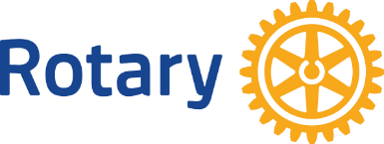

Rotary of Bainbridge is seeking nominations for the “Man of the Year”.

QUALIFICATIONS FOR “MAN OF THE YEAR”
During 2025, the nominee must have been:

• a resident of Decatur County
• an outstanding individual, and
• non-compensated for his voluntary services performed.

The nominations must be in letter form. The letter should state how your nominee has enhanced the quality of life in Decatur County and should explain in detail why you think your nominee should be “Man of the Year”. A panel makes its selection from the information you share in your letter of nomination.

The 2025 “Man of the Year” will be announced at the Chamber Connect luncheon on Thursday, February 5, 2026 at the Charles H. Kirbo Center at the Southern Regional Technical College campus. All nominees will be recognized in the Post-Searchlight.

Please submit your nomination by January 23, 2026, in a letter by email to: Jamie Sinko at jamies@mh-m.org.

If you have any questions, please call Jamie Sinko at 229-220-4591. Thank you in advance for your consideration of this matter. We look forward to receiving your nomination.

Sincerely,
Jamie Sinko, Rotary Club President

